Thomas Travers
CS406
Advanced Software Engineering
Grantham University

Week 1 Assignment
June 13, 2020
1. Dependencies:
Identify the dependencies among the nine use cases for the study abroad application:
- UC1: NONE
- UC2: UC8
- UC3: UC9, UC1
- UC4: UC3
- UC5: UC4
- UC6: UC4
- UC7: UC2
- UC8: NONE
- UC9: NONE
- UC10: UC5, UC7

UC1
- points: 5
- priority: 1
UC2
- points: 4
- priority: 4
UC3
- points: 2
- priority: 1
UC4
- points: 5
- priority: 2
UC5
- points: 3
- priority: 4
UC6
- points: 6
- priority: 5
UC7
- points: 5
- priority: 4
UC8
- points: 5
- priority: 3
UC9
- points: 4
- priority: 2
UC10
- points: 6
- priority: 3

Month 1 | Points | Priority | Month 2 | Points | Priority | Month 3 | Points | Priority
UC1 | 5 | 1 | UC4 | 5 | 2 | UC7 | 5 | 4
UC9 | 4 | 2 | UC8 | 5 | 3 | UC5 | 3 | 4
UC3 | 2 | 1
Total Points: | 11 |  | Total Points: | 10 |  | Total Points: | 8
(Figure 1.1)

Because of dependency issues and priority, I followed the simple rules. Max points per week were 3 equaling to max points per month being 12. I started with cutting out each UC(x) into cards, then placed them all in order by priority. I then found any cards with dependencies. If the dependency was not in front of the card on the list, I placed it in front regardless of it’s priority (because that item can’t be completed without the dependency). If the next item on the list places the month over the 12 points, I placed that item on the top of the list for the following month. I ended up with the table above when completed. Since I can’t go over 12 points per month, the next items in queue would be UC10, UC2, and UC6 in that order.

To make my agile estimation and planning board look a little more like the 5 iteration example, I made the following two boards (full resolution and more readable version files plus their source is included in the project zip file labeled week1source.zip).

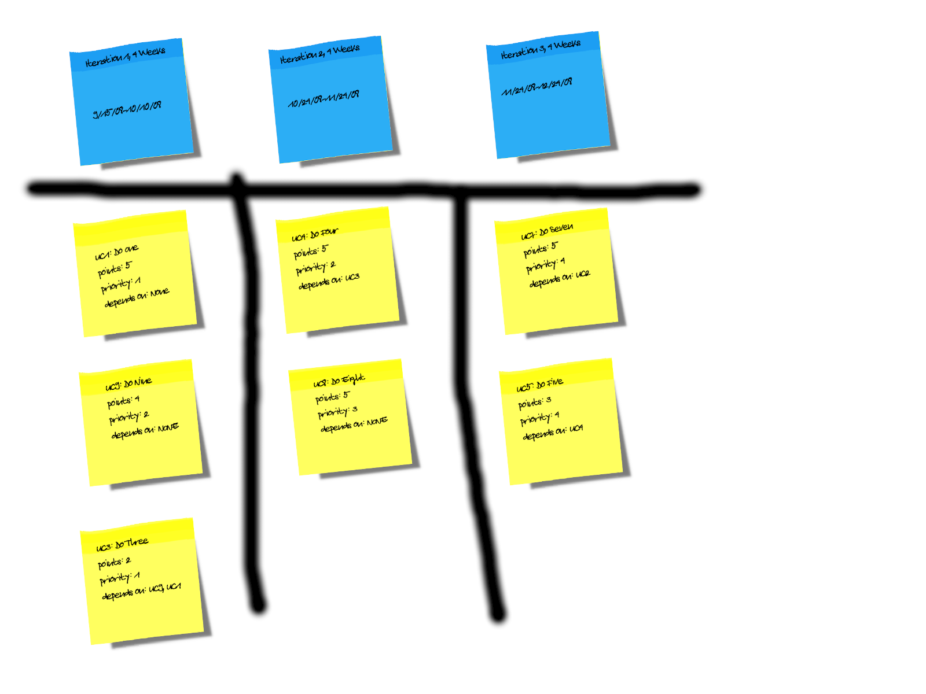
(Figure 1.2)

In figure 1.2, the board displays the organization of my chart in figure 1.1. As previously mentioned, some of the tasks are left out due to dependency issues, and points adding up more than allowed.

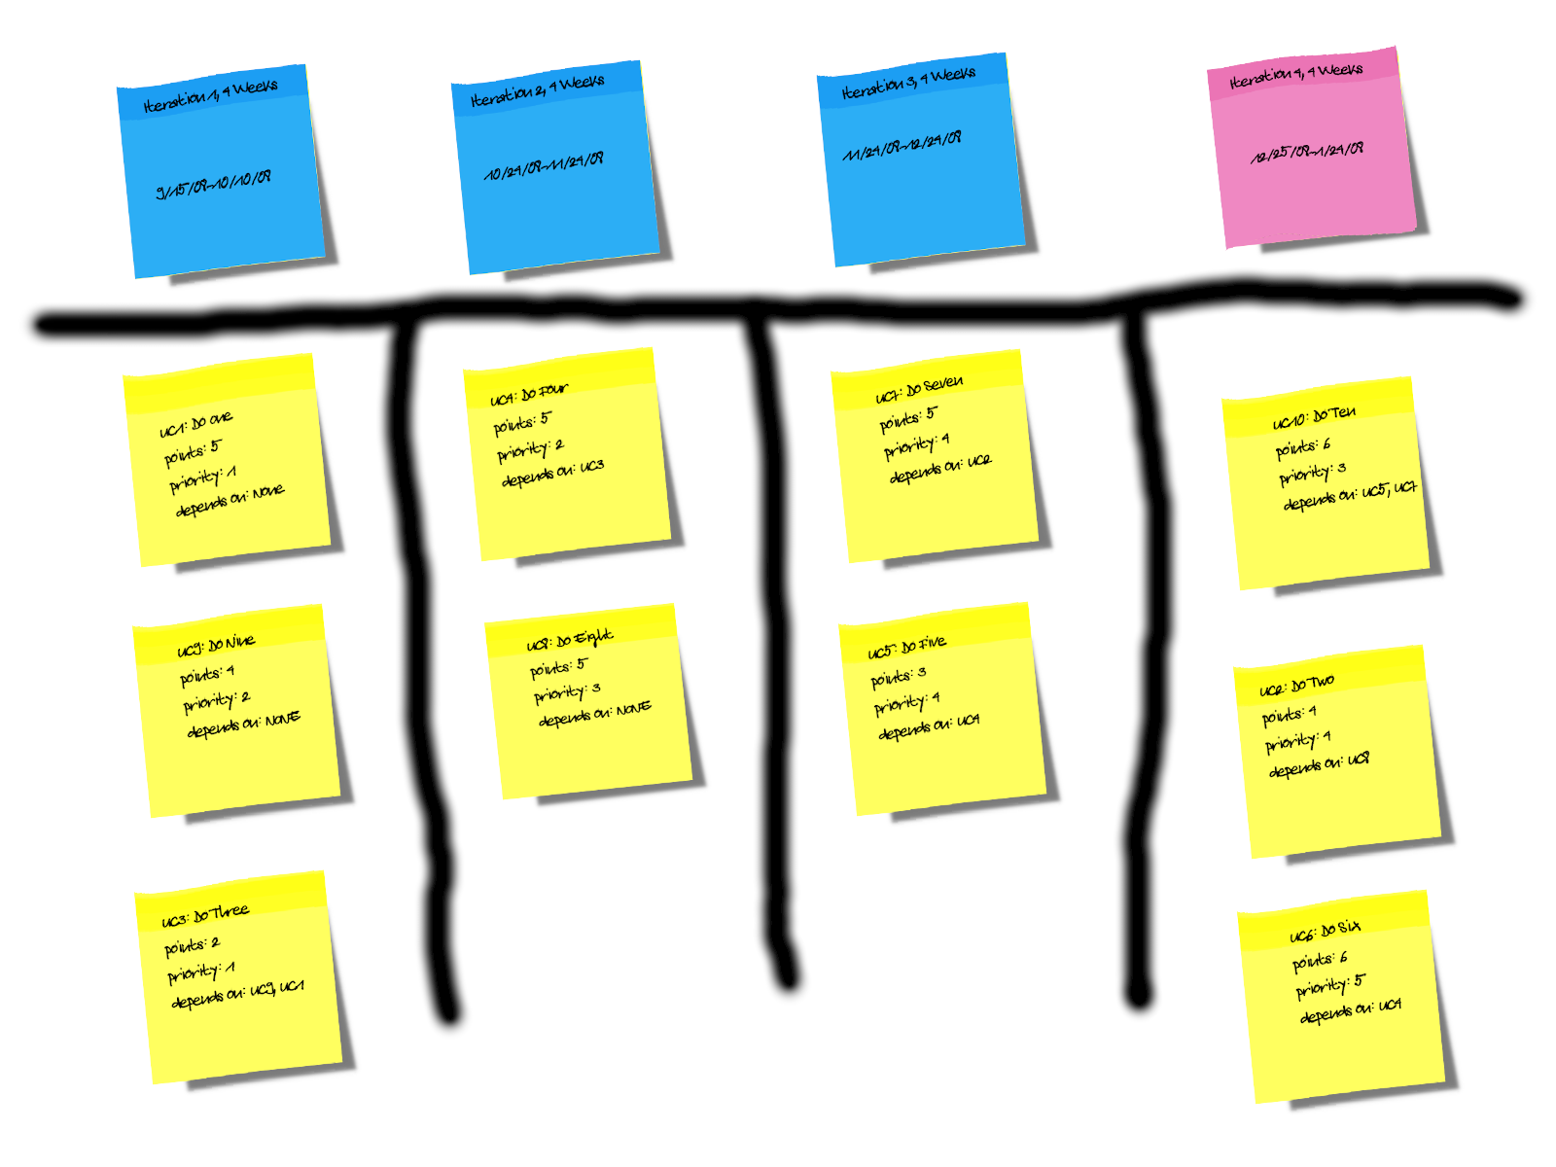
(Figure 1.3)

Figure 1.3 shows the same chart as Figure 1.2 but it adds a column at the end in pink depicting all the tasks not completed in a theoretical 4th month. The points add up to more than 12 allowed for a month but this is just to show the items that got bumped due to priority and dependency issues.

Because the project can not be completed in three one month iterations, there are two possibilities to fix this issue.
(1) Hire more staff - This will add administrative overhead but will allow us to complete the project on time. Since we currently have three staff members and can handle 3 points per week, this would equate to a point per staff member. We can calculate the staffing needed to complete the project on time and hire the correct number of staff members as well as get an accurate measure of cost by knowing their salary. Since some projects come with an expensive penalty for late projects, this would be my most likely of the two solutions.

(2) Extend the project deadline – Since the staff might not be temporary, if there is no staff within the company to allocate to the project, extending the deadline might be a suitable alternative as the company would not have to lay off the extra hired help if they are not needed after the job is completed. Many states including mine allow automatic approval of unemployment benefits for staff layed off without valid termination reason other than lack of work. This sometimes reflects in unemployment insurance cost which adds up over time.
NOTE: The Risk assessment is included in the additional spreadsheet file.

